Diodes: Types and Applications

Shashank Nandan
IEEE SBM
Manipal Institute of Technology
Karnataka, India
shashanknandan21@gmail.com

Abstract—Diodes are semiconductor devices that play a critical role in modern electronics, enabling functionalities such as current rectification, voltage regulation, and signal modulation. By allowing current to flow in one direction while blocking it in the other, diodes form the basis of many electronic systems. This paper provides an in-depth exploration of the properties, working principles, and classifications of diodes. It examines their behavior under different biasing conditions and explores the functionalities of various types, including rectifier diodes, Zener diodes, Schottky diodes, light-emitting diodes (LEDs), photodiodes, and varactor diodes. Emphasis is placed on their unique characteristics, applications, and the impact of recent technological advancements. The comprehensive study underscores the importance of diodes in electronic circuits and highlights their future potential in advanced applications.
Keywords—Diodes, Semiconductor Devices, Rectifier Diodes, Zener Diodes, LEDs, Schottky Diodes, Photodiodes, Varactor Diodes, Applications

Introduction
Diodes are fundamental electronic components that serve as unidirectional current controllers. The introduction of semiconductor materials like silicon and germanium revolutionized diode technology, enabling the development of compact, efficient, and versatile devices. From their initial use in rectification and switching, diodes have evolved to support a wide range of applications, including voltage regulation, signal processing, and optical communication [1][2].
The operation of diodes is based on the PN junction, where the interaction between p-type and n-type semiconductors creates a depletion region. This region governs the diode’s ability to conduct current under specific conditions, defining its behavior in forward and reverse bias [3].
This report delves into the principles governing diodes, explores their classification and working mechanisms, applications and highlights advancements in diode technology. By understanding the properties and applications of different types of diodes, we aspiring engineers can optimize their use in modern electronic systems.

Working principles of diodes

PN JUNCTION
At the heart of a diode lies the PN junction, formed by joining p-type and n-type semiconductors. The p-type region contains holes, while the n-type region is rich in electrons. At the junction, these charge carriers diffuse and recombine, creating a depletion region devoid of mobile carriers. This region establishes a potential barrier that determines the diode’s operational characteristics [4].

Forward And Reverse Bias
•Forward Bias: Applying a positive(or greater) voltage to the p-side and a negative(or smaller) voltage to the n-side reduces the potential barrier, allowing current to flow through the diode.
•Reverse Bias: Reversing the voltage polarity increases the potential barrier, preventing significant current flow except for a small leakage current due to minority carriers [5]

I-V Characteristicss
The I-V characteristics of a diode describe its current response to applied voltage. In forward bias, current increases exponentially after surpassing the threshold voltage (0.7V for silicon and 0.3V for germanium). In reverse bias, the current remains negligible until breakdown occurs [6].

Classification Of Diodes
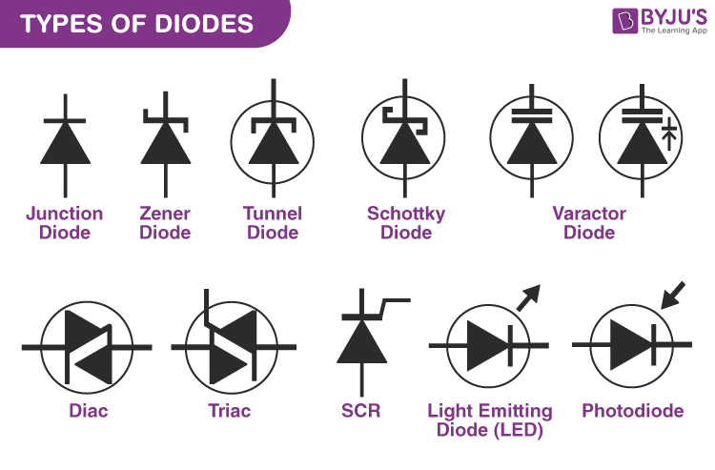

Junction Diodes
It refers to the PN Junction diode which is simply the combination of p-n type semiconductors.

Rectifier Diodes
Rectifier diodes are designed for high current-handling capabilities and are commonly used in power conversion circuits. They convert AC to DC through rectification, with applications in power supplies and battery chargers [7]. The choice of rectifier diodes depends on their current and voltage ratings based on the power requirements of the circuit.
For example 1N4007 is used in Half-Wave Rectifiers and 1N5408 in Full-Wave Rectifiers. Half-wave rectifiers handle only one half of the AC cycle, meaning the current is lower compared to full-wave rectifiers. Full-wave rectifiers conduct in both halves of the AC cycle, meaning they handle more current than half-wave rectifiers.
Parameter | 1N4007 (HW) | 1N5408 (FW)
Max Current | 1A | 3A
Max Voltage | 1000V | 1000V
Forward Voltage Drop | ~0.7V | ~0.8V
Reverse Recovery Time | ~30µs | ~50µs
Application | Low-power | High-power

B. Zener Diodes
Zener diodes operate in reverse breakdown mode to maintain a constant voltage. They are widely used in voltage regulation and protection circuits. Their ability to stabilize voltage makes them indispensable in power supply systems [8].
In forward bias, a Zener diode functions like a normal diode, allowing current to flow through it. However, in reverse bias, it initially blocks current at low reverse voltages. When the applied voltage reaches the breakdown voltage (Vz), the diode starts conducting in the reverse direction, ensuring a stable output voltage. This unique characteristic makes Zener diodes essential for voltage regulation and protection circuits.

Photodiodes
Photodiodes generate current when exposed to light, operating primarily in reverse bias. They are used in solar cells, light sensors, and optical communication systems [10]. Photodiodes operate in two modes: Photovoltaic Mode and Photoconductive Mode. In Photovoltaic Mode (No Bias Applied), the photodiode works like a solar cell, generating voltage when exposed to light, making it ideal for solar power applications. In Photoconductive Mode (Reverse Bias Applied), applying reverse bias widens the depletion region, reducing capacitance and improving response time, which is essential for high-speed optical sensors such as those used in fiber optic communication.

D. Light-Emitting Diodes
LEDs emit light when electrons recombine with holes in the semiconductor material. Their energy efficiency and long lifespan have made them popular in lighting, displays, and communication technologies [9].An LED emits light when an electric current flows through it. It works on the principle of electroluminescence, where electrons recombine with holes to release energy in the form of photons. LEDs are widely used in displays, indicators, and lighting applications due to their energy efficiency and long lifespan.
When the diode is forward biased, the minority electrons are sent from p → n while the minority holes are sent from n → p. At the junction boundary, the concentration of minority carriers increases. The excess minority carriers at the junction recombine with the majority charges carriers. The energy is released in the form of photons on recombination. In standard diodes, the energy is released in the form of heat. But in light-emitting diodes, the energy is released in the form of photons. The colour of an LED is determined by the material used in the semiconducting element.
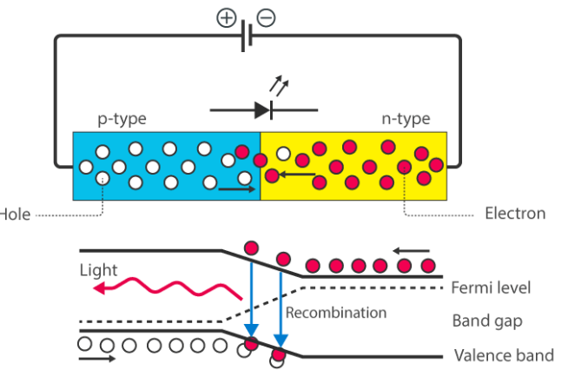

D. Schottky diodes
Schottky diodes feature a metal-semiconductor junction, resulting in low forward voltage drop and fast switching speeds. They are ideal for high-frequency and power applications [11]. A Schottky diode has a low forward voltage drop (~0.2V - 0.4V) and fast switching speed, making it ideal for high-frequency and power rectification in switching power supplies, RF circuits, and solar panels. Unlike conventional PN-junction diodes, it is constructed with a metal-N-type semiconductor junction, making it a unipolar device with no depletion layer. The most common material used is silicide, which provides low resistance and a typical forward voltage drop of 0.3V - 0.5V, depending on the metal compound used.

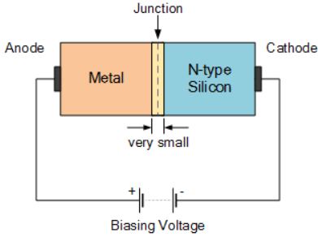

E. Varactor diodes
A varactor diode, also known as a varicap diode, functions as a variable capacitor by changing its capacitance with an applied reverse voltage. It is widely used in radio frequency (RF) circuits, where electronic tuning is required without mechanical components. These diodes are essential in tuned circuits, frequency modulators, automatic frequency control (AFC) circuits, and voltage-controlled oscillators (VCOs) used in TV tuners, satellite receivers, and mobile communication systems. Their ability to dynamically adjust capacitance makes them crucial for modern wireless communication. [12].

F. Laser diodes
A laser diode emits coherent, monochromatic, and high-intensity light, unlike an LED, which emits incoherent light. It works on the principle of stimulated emission in which photons trigger the emission of additional photons with the same phase and wavelength, creating a highly focused beam. These diodes are commonly used in CD/DVD/Blu-ray drives, barcode scanners, fiber-optic communication, laser pointers, and medical instruments like laser surgery tools. Due to their high power output, laser diodes require precise current control to prevent overheating and damage.

G. Tunnel diodes
A tunnel diode is a special type of diode that exhibits negative resistance, meaning its current decreases as voltage increases over a specific range. This behavior is due to quantum mechanical tunneling, where electrons pass through the potential barrier at very low voltages without needing additional energy. Tunnel diodes operate at high frequencies (GHz range) and are used in oscillators, amplifiers, microwave circuits, and high-speed switching applications. Their ability to function at extreme speeds makes them valuable in radar and satellite communication systems.

H. Avalanche diodes
An avalanche diode is designed to operate in reverse bias and relies on avalanche breakdown, where high reverse voltage causes accelerated electrons to collide with atoms, generating more free electrons and leading to a large reverse current. These diodes are commonly used in high-voltage protection circuits to absorb voltage spikes and in voltage regulation applications. Avalanche diodes are found in surge protectors, power supply units, and RF transmission circuits where overvoltage protection is critical.
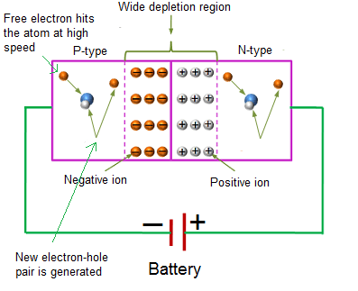

Applications
Diodes play a crucial role in electronics, allowing current flow in one direction while blocking it in the other. This unique property makes them essential for power conversion, voltage regulation, signal processing, and protection circuits. Mentioned are some major applications of diodes:

Inrush Current Protection
Inrush current protection is an important application where diodes help prevent sudden surges of current when a device is powered on. Schottky diodes, with their fast response and low forward voltage drop, are often used to limit inrush current in power supply circuits. Avalanche diodes are also used to absorb voltage spikes, preventing damage to sensitive components in devices like power adapters, motor drives, and industrial control systems.

Rectification
Rectifier circuits use diodes to convert AC (alternating current) to DC (direct current). Half-wave rectifiers use a single PN junction diode (e.g., 1N4007) to allow only one-half of the AC cycle, whereas full-wave rectifiers use four diodes in a bridge rectifier configuration to allow both halves of the AC cycle, providing a smoother DC output. Schottky diodes are preferred in high-frequency rectifier circuits due to their fast switching speed and lower voltage drop, making them suitable for DC power supplies, battery chargers, and voltage conversion circuits.

Voltage Regulators
Voltage regulator circuits make use of Zener diodes, which operate in reverse bias to maintain a constant output voltage, ensuring voltage stability even when the input fluctuates. When the input voltage exceeds the Zener breakdown voltage (Vz), the diode conducts in reverse, stabilizing the voltage. Common Zener diodes include 1N4733A (5.1V), 1N4742A (12V), and 1N4749A (24V), which are widely used in power supplies, voltage reference circuits, and overvoltage protection applications.

Clipping & Clamping
Clipping and clamping circuits also rely on diodes to shape and modify electrical waveforms. Clipping circuits are used to limit voltage peaks, ensuring that signals remain within a desired range, which is essential in audio processing, waveform shaping, and RF transmission circuits. Clamping circuits, on the other hand, add a DC shift to AC signals, keeping them within a specific voltage range. These circuits are commonly found in TV receivers, oscilloscopes, and voltage stabilizers. Schottky diodes are often used in high-speed clipping applications due to their fast response times.

Signal Detection
Signal detection circuits extensively use photodiodes, which operate in reverse bias and generate a photocurrent when exposed to light. This property makes them useful in light sensors, fiber-optic communication, barcode scanners, and medical imaging devices. Avalanche photodiodes provide high sensitivity, making them ideal for low-light detection applications. Additionally, laser diodes are used in optical data transmission, such as CD/DVD drives, LiDAR systems, and high-speed fiber-optic internet communication.

LEDs
LED circuits utilize Light Emitting Diodes (LEDs), which emit light when forward biased, converting electrical energy into light energy. They are widely used in indicator lights, automotive lighting, traffic signals, and display panels. A specialized form of LEDs, laser diodes, produce coherent light and are used in laser pointers, barcode scanners, and fiber-optic communication systems.

Some other applications
Beyond these applications, diodes are used in any circuit where current needs to flow in only one direction. For example, in reverse polarity protection, diodes prevent damage when power is connected incorrectly in battery circuits, automotive electronics, and consumer devices.
In freewheeling circuits, diodes protect inductive loads such as motors and relays from voltage spikes caused by sudden switching. Varactor diodes (Varicap diodes) serve as variable capacitors in radio frequency tuning circuits, satellite receivers, and TV tuners, allowing electronic tuning without mechanical components.
Tunnel diodes, with their unique negative resistance property, are used in microwave amplifiers, oscillators, and high-speed switching circuits, making them essential for radar and satellite communication systems.

Conclusion

Diodes are indispensable components in modern electronics, providing functionalities essential to power conversion, signal processing, and optical communication. Their diverse types and applications underscore their versatility and importance. As advancements in materials and fabrication techniques continue, diodes will remain at the forefront of electronic innovation, supporting the development of more efficient, reliable, and compact systems.

Acknowledgment
I would like to express my gratitude to the electronics domain of IEEE SBM at Manipal Institute of Technology, Manipal Academy of Higher Education, for providing me with the opportunity to contribute to this report during my Work Comm. under electronics Domain.

References

- History of Diodes. Available: https://www.electronics-notes.com/articles/electronic_components/diode/
- PN Junction Basics Available: https://www.electronics-tutorials.ws/diode/diode_2.html
- Forward and Reverse Bias. Available: https://www.electronics-tutorials.ws/diode/diode_3.html
- Rectifiers: https://www.circuitdigest.com/tutorial/rectifier-diodes
- ZenerDiodes:https://www.circuitdigest.com/tutorial/zener-diode
- LEDs and Applications. Available: https://www.digikey.com/en/articles/understanding-leds
- Photodiodes. Available: https://www.thorlabs.com/newgrouppage9.cfm?objectgroup_id=285
- SchottkyDiodes.Available:https://www.allaboutcircuits.com/technical-articles/introduction-to-schottky-diodes/
- Varactor Diodes. Available: https://www.rfwireless-world.com/Terminology/Varactor-diode-applications.html
- Advanced Diode Materials. Available: https://www.powerelectronics.com/sic-gan-diode-advantages
- H. C. Verma, "Concepts of Physics," Bharati Bhawan Publishers, 2002 [12] Maxwell’s Equations and Applications. Available: https://www.khanacademy.org/science/physics/electrostatics
- Faraday’s Law and Optical Advancements. Available: https://www.britannica.com/science/Faradays-law-of-induction

